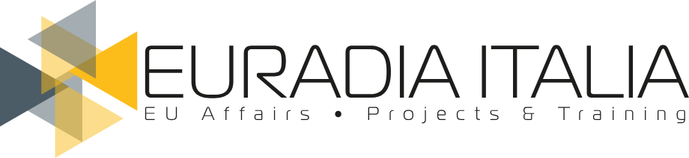
PRESS RELEASE · 13 January 2025
KEA and Euradia: nurturing the cultural and creative sectors in Europe together
The two firms pool their expertise in culture, creativity, youth, social affairs and sport, between Brussels, Rome and Florence.

KEA European Affairs, a leading Brussels-based consultancy specialised in culture, the creative industries and sport, and Euradia Italia, a boutique consultancy with long experience in direct and indirect funding, in local and European projects, and in institutional relations and events, are pleased to announce a strategic alliance.
Euradia Italia is based in Rome and Florence, and its natural focus on the cultural and creative sectors, youth, social affairs and sport converges fully with KEA's, making this alliance a perfect match both geographically and in terms of specialisation. Together, the two firms will pool their expertise and proven track record in European project design and management, capacity building and technical support for public and private organisations to deliver high-quality consultancy at two levels: services tailored to the needs of Italy's cultural and creative sectors, and joint action at EU level.
Key aspects of the partnership include joint consultancy offerings, shared resources including shared flagship offices, and the co-design of projects for Italian, European and international cultural and creative organisations.

A focus on the Italian market
The partnership is built on a shared vision and common values. As KEA and Euradia embark on this journey, they look forward to strengthening ties with stakeholders across Italy. For more information or partnership opportunities, please contact:
- Federica Antonucci · fantonucci@keanet.eu
- Massimo Macaluso · massimo.macaluso@euradiaitalia.eu
KEA and Euradia team up to unlock the potential of Italy's cultural and creative sectors.
Press contact: press@euradiaitalia.eu · www.euradiaitalia.eu/en/press/kea-euradia/

